Take a new operation in charge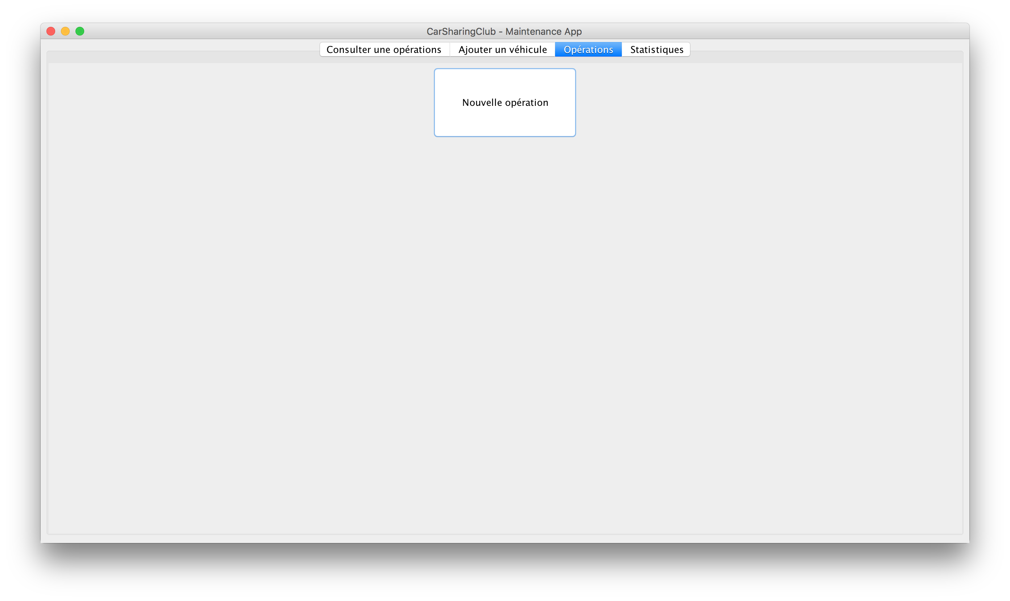

By clicking on the tab « Opérations » you get a view with a single button « Nouvelle opération ».

When you’ll click on it, it will open a new window that will display the information of the most urgent operation in the prioritized list of operations. It also updates the status of the operation to IN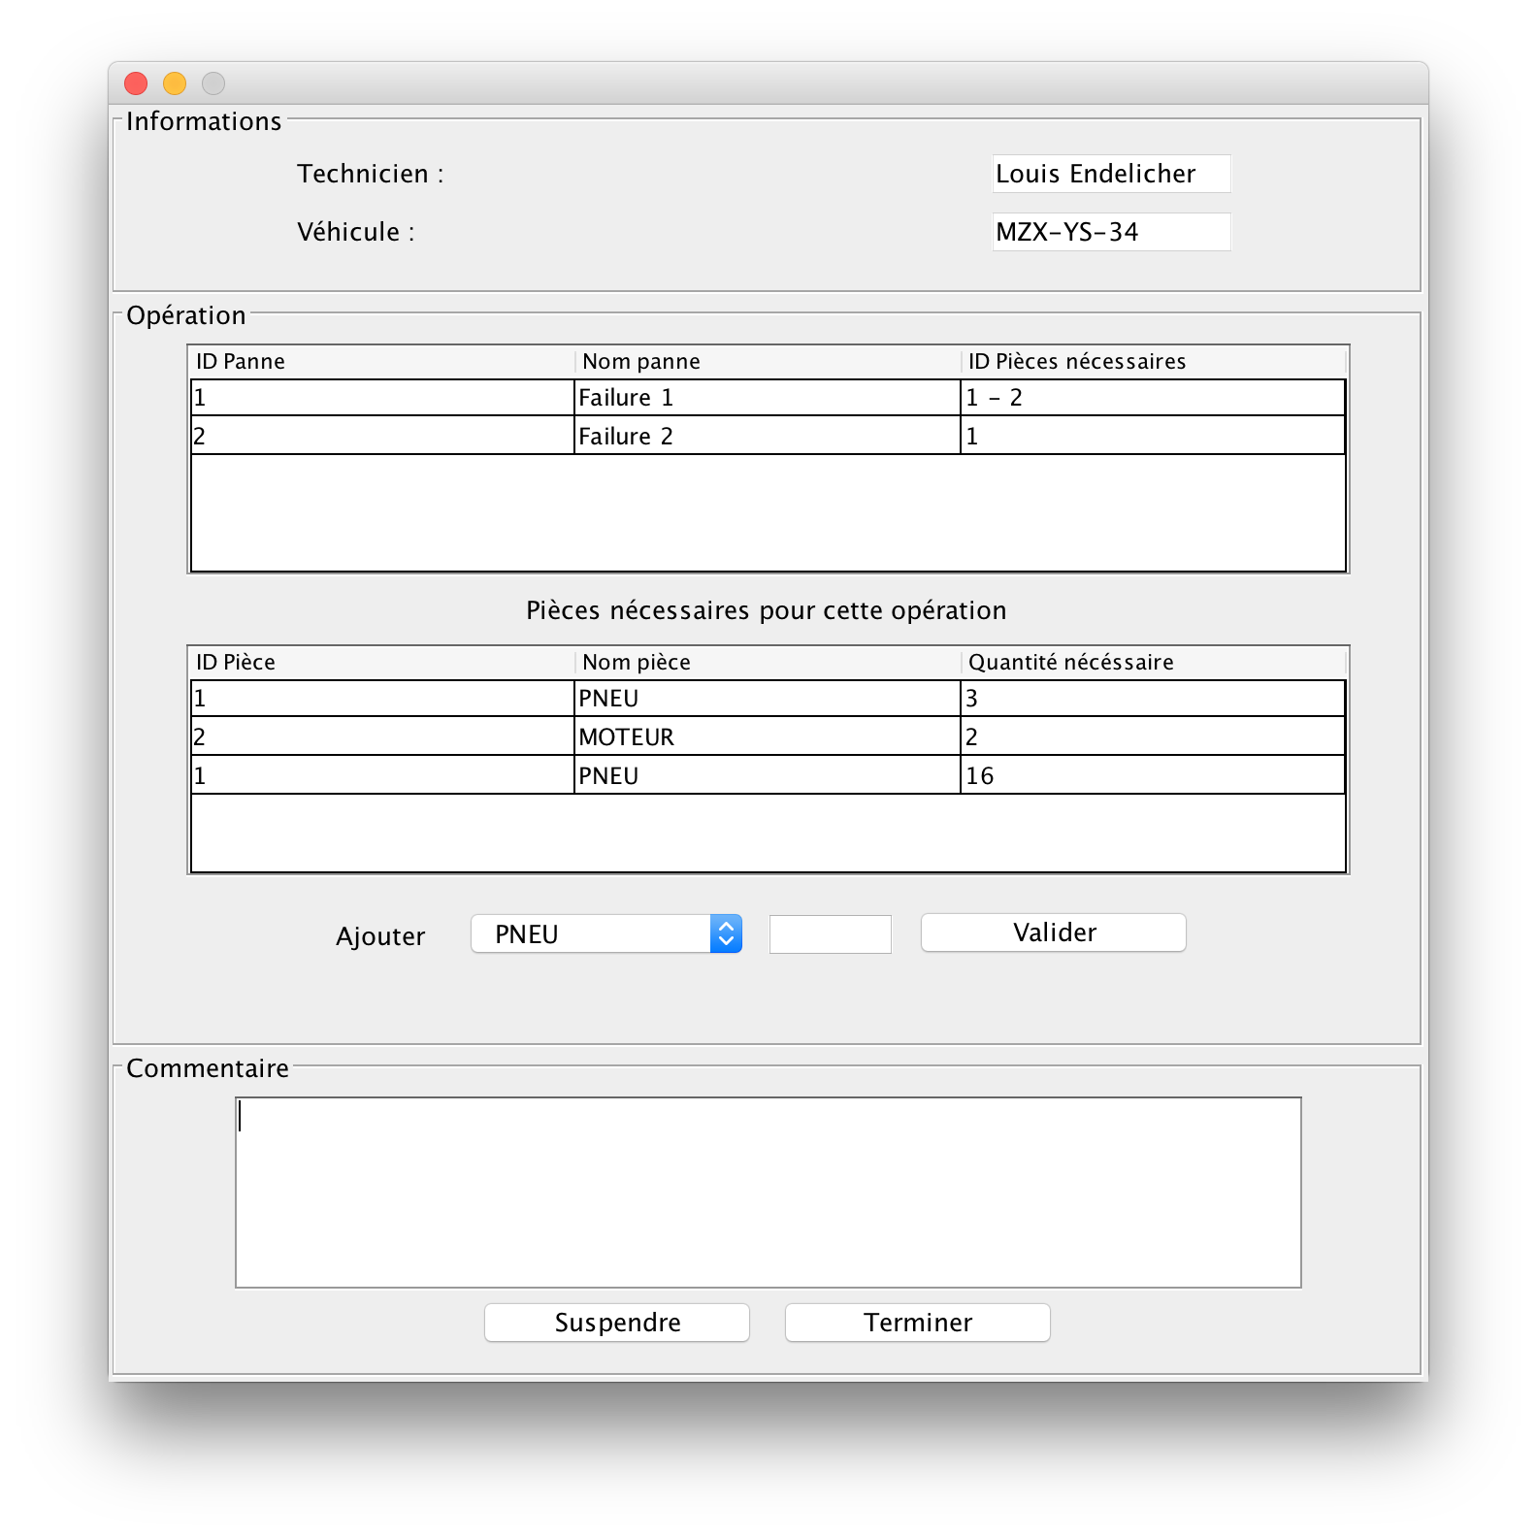 PROGRESS : « réparation en cours » and sets the current date as the beginning of the repair.

Is displayed in this window (for this operation) :

* some information about the technician namely his first and last name ;
* the immatriculation of the vehicle ;
* a table with all the failures : the ID, the name, the IDs of the parts needed for this failure ;
* another table with the ID, the reference and the quantity of every parts needed to fix all the failures ;
* a list where you can select a part and a quantity to use, if you need more parts (for exemple if one is defective…) and click the « Valider » button to validate ;
* a comment section ;
* two buttons « Suspendre » to suspend and « Terminer » to finish the operation.
* What appends when you add a part for the operation ?

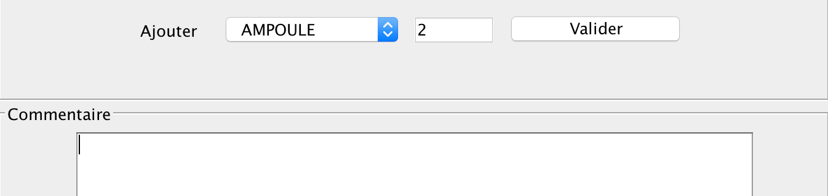

The system updates the stock of the part and will add in the comment area the information to permit you to track the additional parts of every operation easily.

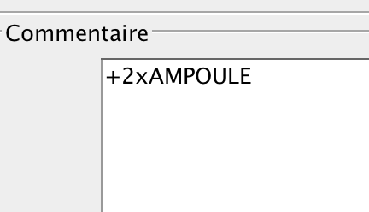

* What appends when you click the button when you suspend the operation ?



The system updates the status to SUSPENDED : « suspendue » of the operation in the database with the actual date, attributes a free parking space to the vehicle and sets the comment of the technician. When an operation is suspended it automatically changes it’s priority to top. The window of this operation closes.

* What appends when you click the button when you suspend the operation ?

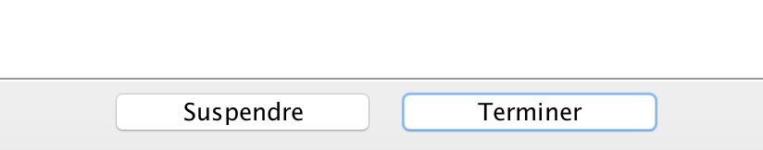

The system « closes » the operation by updating the status of the operation to REPAIRED : « réparé », the stock of all the parts used for the operation, attributing a free parking space to the vehicle and setting the new comment of the technician. The window of this Operations closes.